**PROJECT REPORT**

**THE TRAGEDY OF FLIGHT: A COMPREHENSIVE CRASH ANALYSIS**

**1. Introduction:**

**1.1Overview:**

* for improving safety and preventing similar accidents in the future. These recommendations An airplane crash analysis is a detailed investigation into the causes of an aviation accident. The goal of an airplane crash analysis is to identify any factors that contributed to the accident, with the ultimate goal of improving safety and preventing future accidents. The process of conducting an airplane crash analysis typically involves the collection and analysis of a wide range of data, including information about the aircraft and its systems, the operators, and any other relevant factors. This data is typically collected from Kaggle. Once the data has been collected, it is analysed through tableau, to identify any potential causes of the accident. The results of an airplane crash analysis are typically published in a report, which may include recommendations for improving safety and preventing similar accidents in the future. These recommendations may be implemented by the relevant authorities or industry organizations.

**1.2Purpose:**

* The results of an airplane crash analysis are typically published in a report, which may include recommendations may be implemented by the relevant authorities or industry organizations.

**2. Problem definition & Design Thinking:**

**2.2 Empathy Map:**

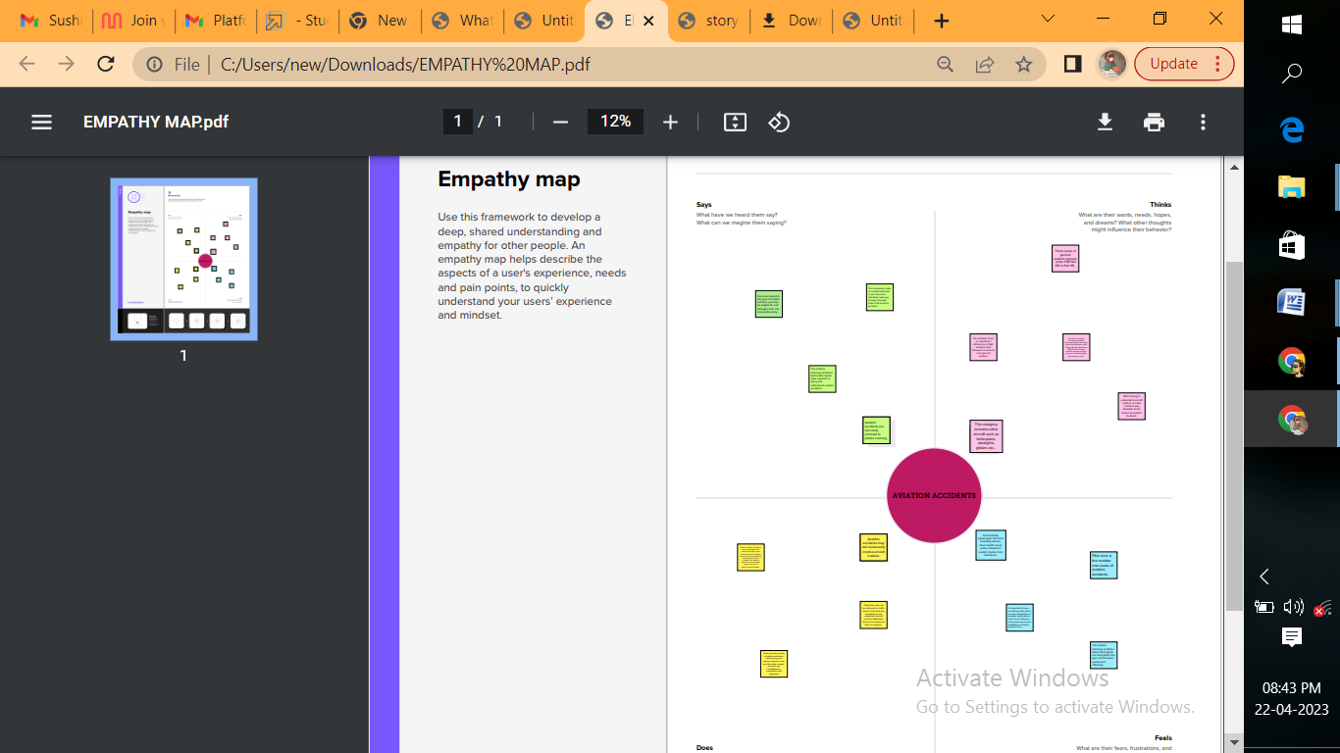

2.2 **Ideation & Brainstorming map:**

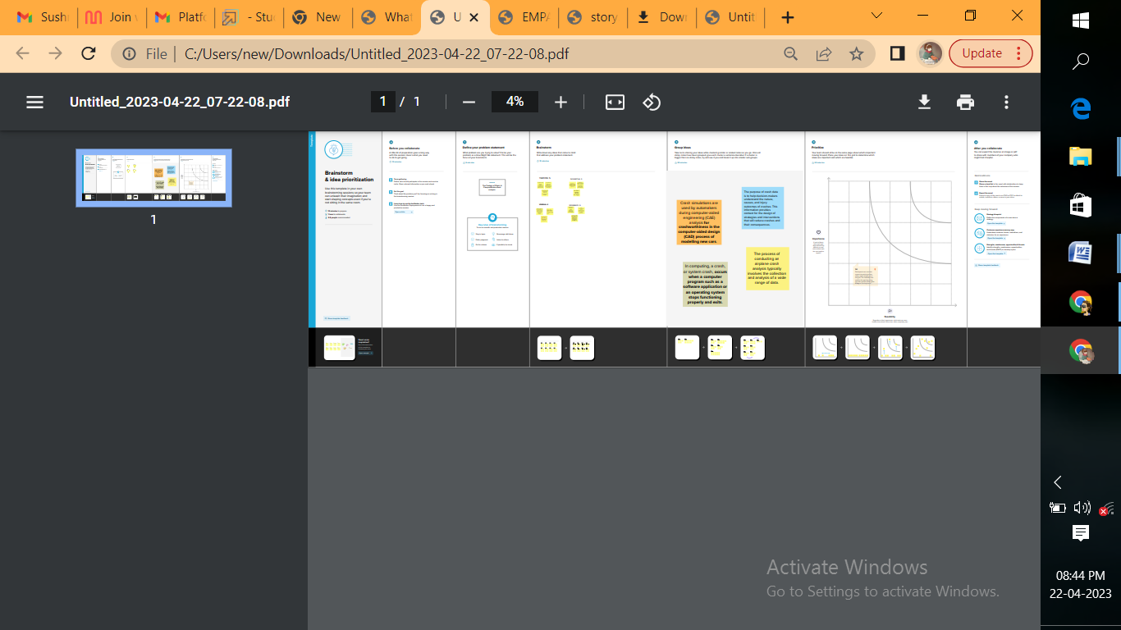

**3.Result:**

* They should be alert at all times and give clear instructions to the pilots. All these measures will help to avoid accidents caused by human error.
* It is important to have proper maintenance and inspection procedures in place so that such problems can be detected and fixed before they lead to an accident. Overall, there are many different causes of airplane crashes.

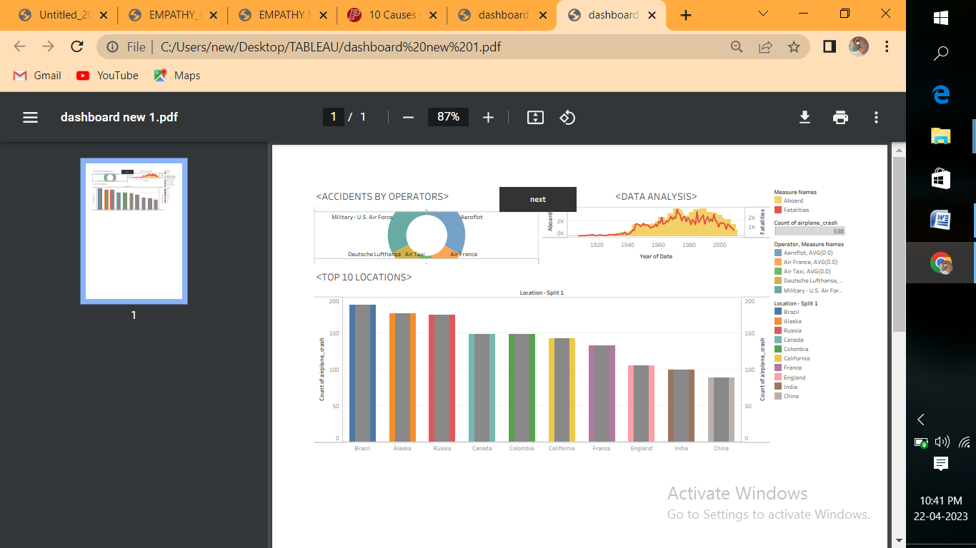

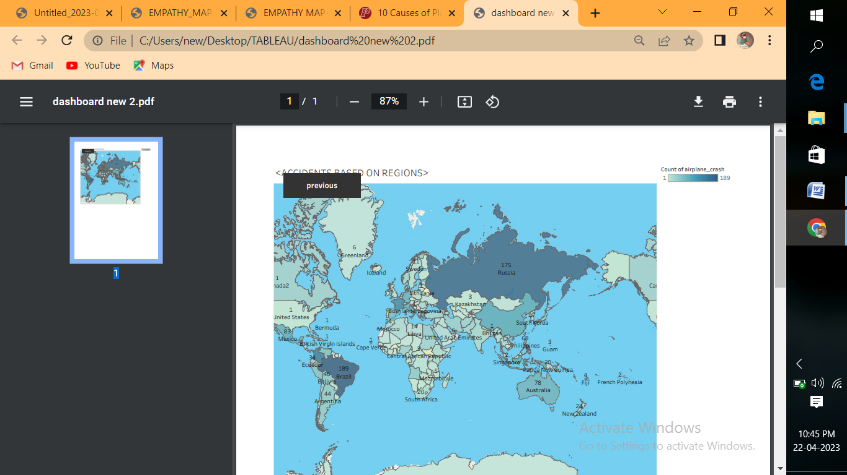

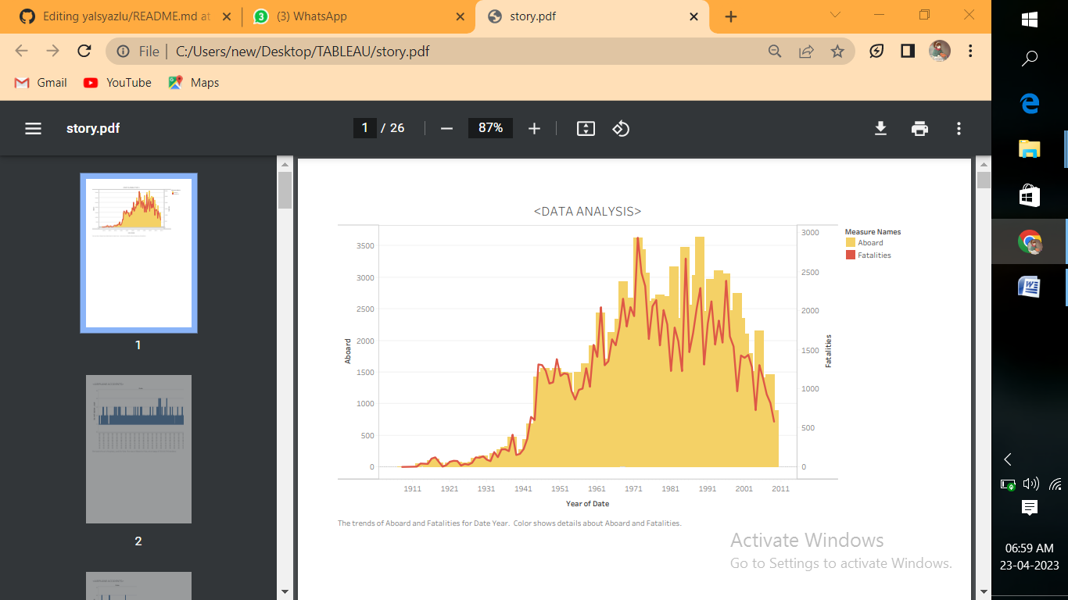

**4.Advantages and disadvantage**s:

* there have been many cases where the wrong information was passed on to the pilot, resulting in an accident. For example, in 2013, Asiana Airlines Flight 214 crashed while landing at San Francisco International Airport.
* The reason for the accident was that the ground workers gave incorrect instructions to the pilot. This led to the plane hitting the seawall and eventually crashing.

**5.Application:**

* It is important for ground workers to be properly trained. They should know how to communicate with the pilots and pass on the correct information. Also, they should be aware of the potential hazards around the airport so that they can warn the pilots about them.
* It is important for everyone involved in flying the plane to have clear and concise communication. There should be no room for misunderstanding or confusion. All instructions must be conveyed clearly, and everyone must be on the same page.

**6.Conclusions:**

* Overall, there are many different causes of plane crashes. By taking some preventive measures, the risks can be reduced. However, accidents can still happen even if all the safety measures are in place.
* Therefore, it is important to be prepared for an accident and know what to do in such a situation. All members of the crew and passengers should be aware of the safety procedures so that they can act quickly and efficiently in the event of an accident.

**7.Future Scope:**

**Avoid Flying in Areas Where There is a High Risk of Bird Strikes**

* One of the leading causes of airplane crashes is bird strikes. To avoid this, it is important to avoid flying in areas where there is a high risk of bird strikes. Pilots should be aware of these areas and take measures to avoid them.

**Improve The Air Traffic Control System**

* The air traffic control system is very important for the safety of airplanes. It is responsible for coordinating the movement of planes in the sky. To avoid accidents, it is important to improve the air traffic control system.

**Train Ground Workers Properly**

* Groundworkers play a very important role in the safety of airplanes. They are responsible for fueling the plane, checking the engine, and loading the baggage.

**8.Appendix:**

A source code: https://public.tableau.com/views/story_16821733768980/Story1?:language=en-US&publish=yes&:display_count=n&:origin=viz_share_link